Section A
- Which correctly shows the equation that links pressure, force and area

Tick (✓) one box.

$$Pressure= Force ×Area$$ | 
$$Pressure= \frac{Force}{Area}$$
$$Pressure= \frac{Area}{Force}$$
- Which property of liquids makes them useful in hydraulic systems?

Tick (✓) one box.

They cannot be compressed
They can be compressed
They do not have a fixed shape
They can flow

- Draw a particle diagram to show the arrangement of particles in a liquid.

- Using your particle diagram and your own knowledge, describe the movement of particles in a liquid.

___________________________________________________________________________________

___________________________________________________________________________________

Section B

- The diagram shows a container filled with water. The water exerts a force of 38 N on the bottom of the container.

The bottom of the container has a surface area of 0.005 m².

Calculate the pressure exerted by the water on the bottom of the container.

______________________________________________________
______________________________________________________
______________________________________________________

Circle the correct unit.
m²/N Nm Pa

- The diagram below shows the hydraulic system used in a car lift. An operator presses a control button which applies a force to the master piston. This makes the slave piston produce a force acting upwards, which lifts the car.

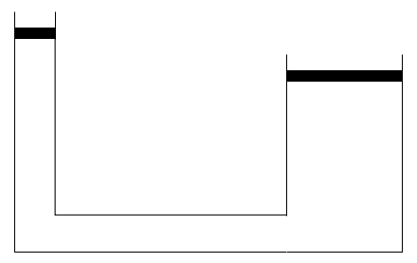
Cross-sectional area of master piston = 0.052 m²
Cross-sectional area of slave piston = 0.84 m²

Hydraulic liquid

- When a force is applied to the master piston, it results in a much larger force acting upwards on the car. Use information from the diagram to explain why.

___________________________________________________________________________________

___________________________________________________________________________________

___________________________________________________________________________________

___________________________________________________________________________________

___________________________________________________________________________________
- A force of 990 N is applied to the master piston. Calculate the force applied by the hydraulic liquid to the slave piston.

___________________________________________________________________________________

___________________________________________________________________________________

___________________________________________________________________________________

___________________________________________________________________________________
- Calculate the maximum mass of a car that could be lifted by this car lift. Take gravitational field strength as 10 N/kg.

___________________________________________________________________________________

___________________________________________________________________________________

Section C

- Hydraulic systems are also used in car braking systems.
- Explain why hydraulic brakes contain fluid.
- Compare the size of the force applied by a person’s foot to the brake and the force applied by the brakes on the wheels.
- Sketch a velocity-time graph to show a car moving at a steady speed before the driver applies the brake and slows down to a stop.

